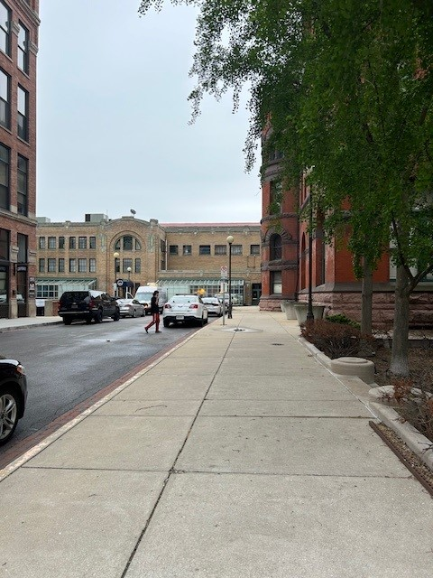Vendor parking available

Outside of these times:

5:30am-5:45am

1:30pm-1:45pm

9:30pm-9:45pm

In accordance with

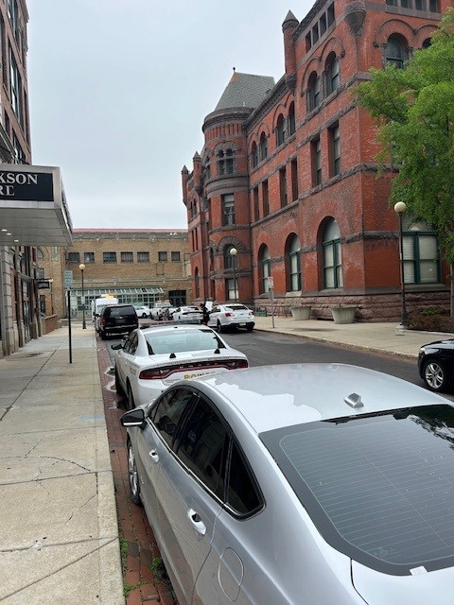your contact.